**Java Script Code Execution and Call Stack**

**Java Script Code Execution:-**

the steps on how the javascript executes its Code:-

1. Global Execution --> this is stored/made
2. memory phase --> creates and store the memory of the objects, variables, functions,exe
3. Execution Phase --> creates new execution environment (later deletes itself)
   1. Create a memory phase and Execution phase in itself for the function

Diagram:-

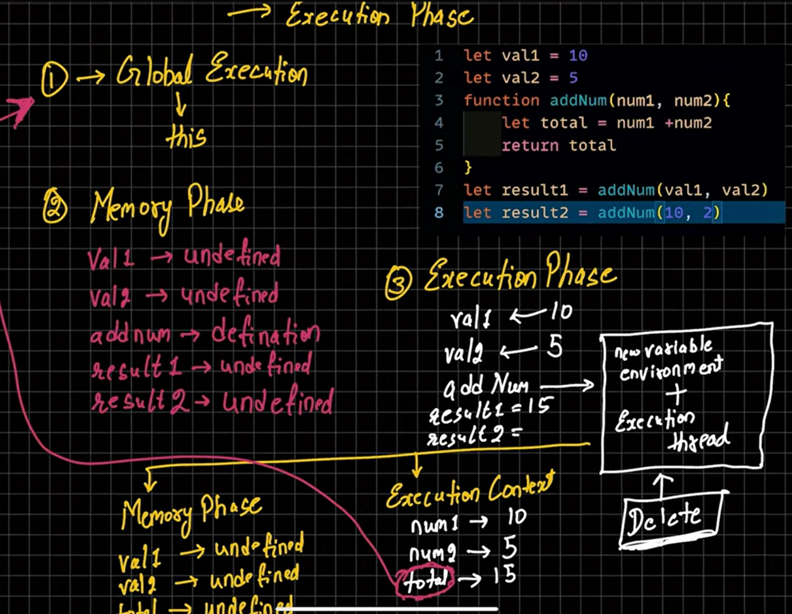

**Call Stack:-**

**How functions are placed in the execution context**

**Lifo (last in first out)**

**Stack**